Project Plan

I’m going to make a website named as fish and Chips Shop because by using this website we can improve business and advertised our business by using following tools

**Goals and Success Evaluation:**

1. There should be registration form by providing customer email and cell phone they can register in our website and get discount vouchers. On the other way we can do update customer for specific event and deals by sending them notification etc.
2. SEO (search engine optimization) will help you gain better rankings in search engine result pages and this translates to more targeted visits and essentially to more customers
3. There should be ranking system. With getting more ranking our website keep top position in search engine and people like to visit and trust more rank brand. So in this way we can promote our business.
4. SEO helps us to make our website more navigable for search engine as well as for users. It’s rearrange site architecture as well as makes links to for website easier to find and navigate.
5. Website which has more ranking it also gains more exposure on social media. There is very strong relationship between social media and SEO because popularity in social media is good for SEO and SEO conveys more visibility of social media.

### Target Audience:

1. Our target customers are those peoples which are health conscious. Especially peoples more than 30 year old because we provide fresh and healthy seafood which attracts the people’s which are health cognisant.
2. As me mentioned in our website about us page we provide fresh Seafood and also mentioned all the ingredients which we put inside any food which attracts the people and make easier to decide what they exactly want .
3. By looking our target audience we design our website and website colour scheme is designed according to audience by taking there feedback and comments we improve it to make it more attractive.

**Flow Chart:**

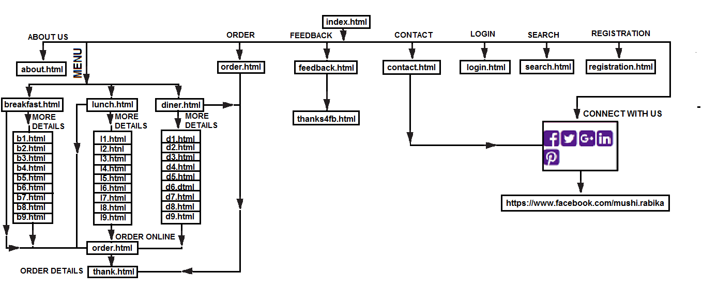

**Home Page (index.html):**

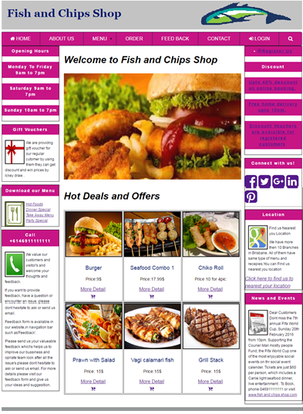

Home page is saved as index.html. In home page in navigation bar there is link of about us, Menu, Order, Feedback, Contact, Login and Search Similarly in the left column there are different menus such as hot deals , dinner , party dinner etc. all are linked with our menu page so by clicking them customer can do to specific menu which he want. Then in the top of main column there image slider which shows the pic of different food and then there are hot deals option where there are different hot details are there with different option either customer direct can put order or can so to more details and see all the available ingredients inside the product and then can put order.

Following are the hot deals products where are shown on home page.

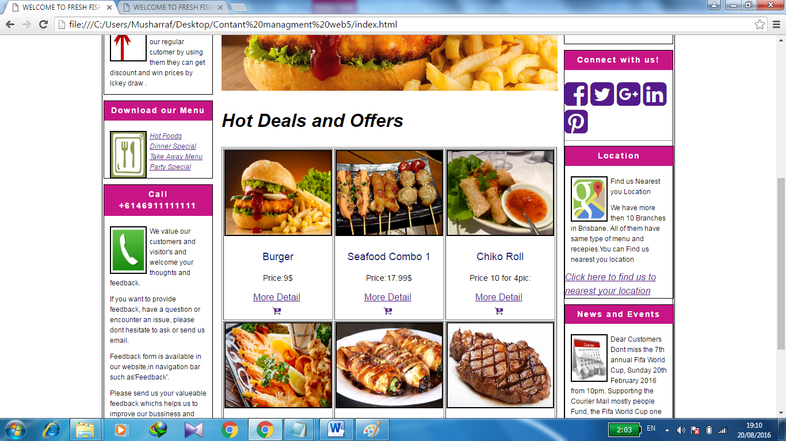

If the custoemr click on more detalis so detalis form open such as

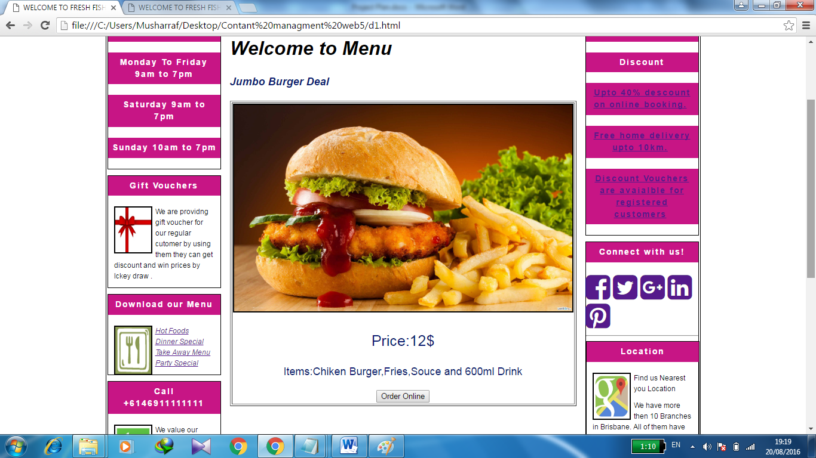

So after than customer can put order online after visiting orderonline page or direct such by clicking order online button so following form appears

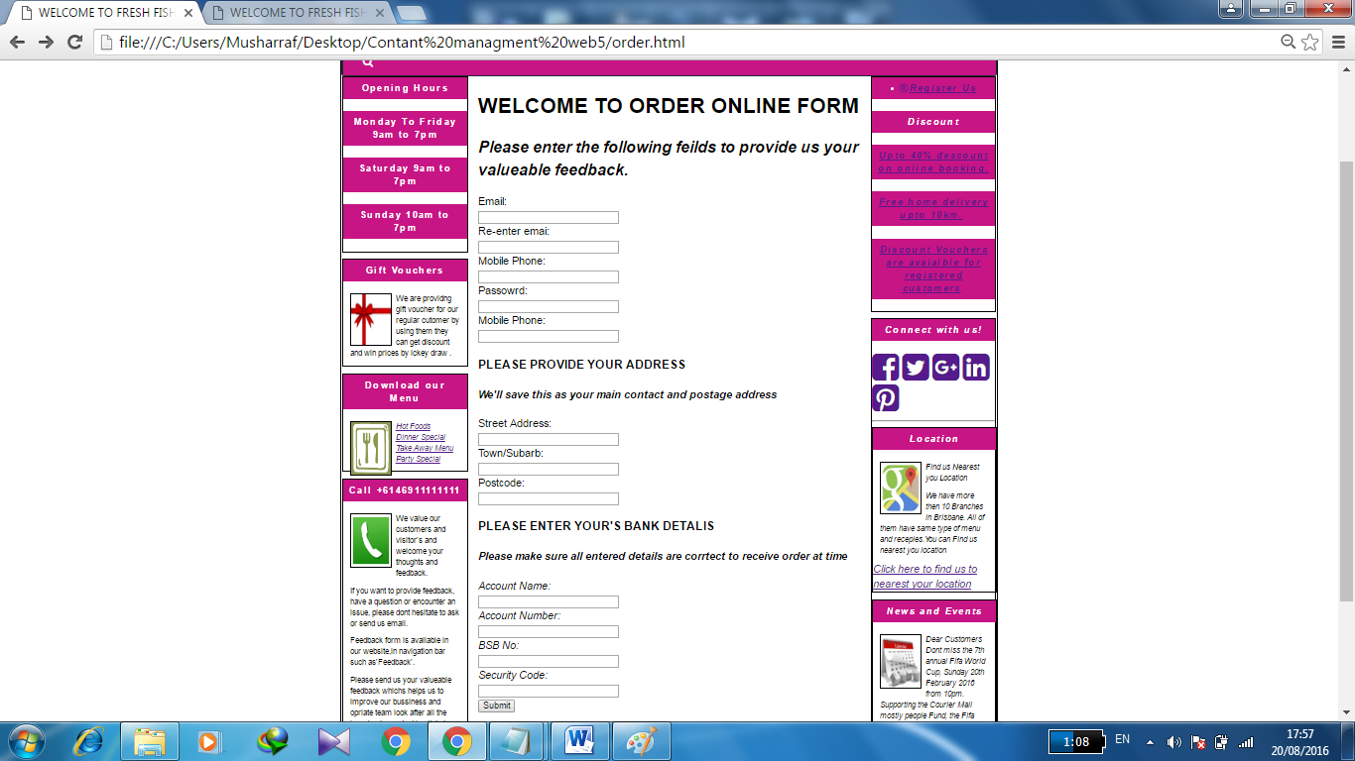

After butting all the infromtion when customer put submission button so order detalis form appers in which there is detailed infromation regarding to order such as

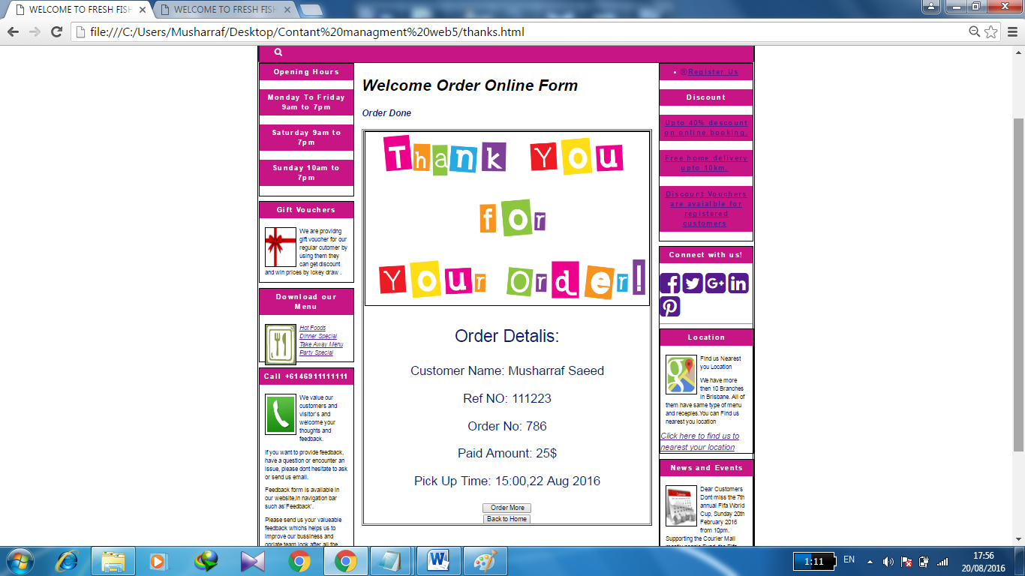

Same method is repeated for all the product and custoemer can put oder online by using same method.Following are the products of hot deals whoch are in hoem page.





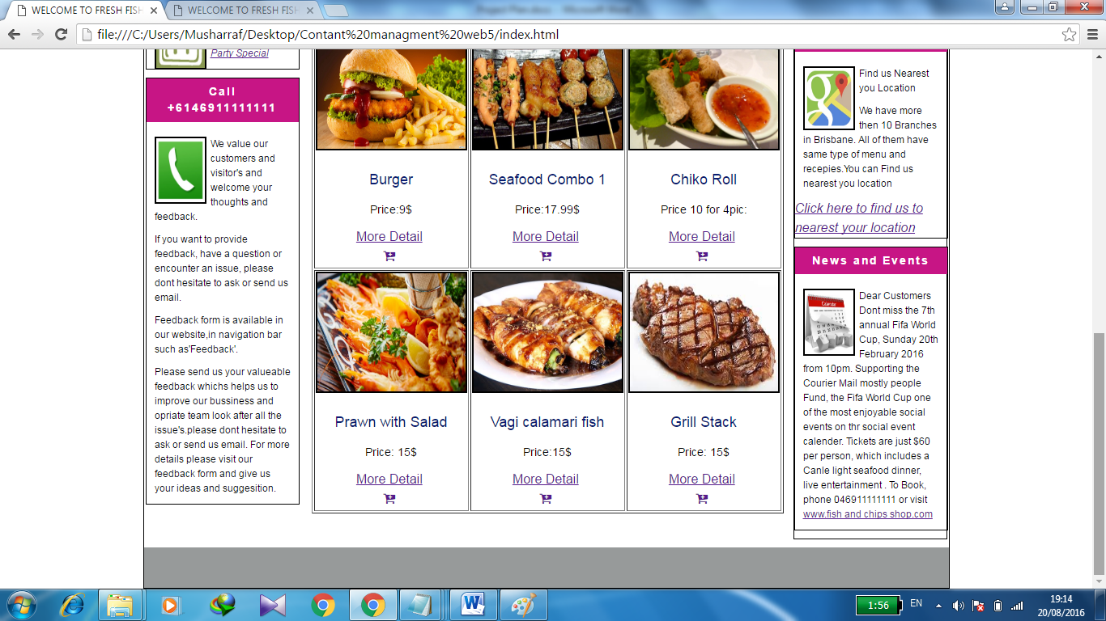





**MENU:**

There is drop box Menu in which there are 3 categories such as

1. **BREAFAST (breakfast.html)**
2. **LUNCH (lunch.html)**
3. **Dinner (diner.html)**

All using same technique for more details and order online booking method which described above:

1. **BREAFAST (breakfast.html):**

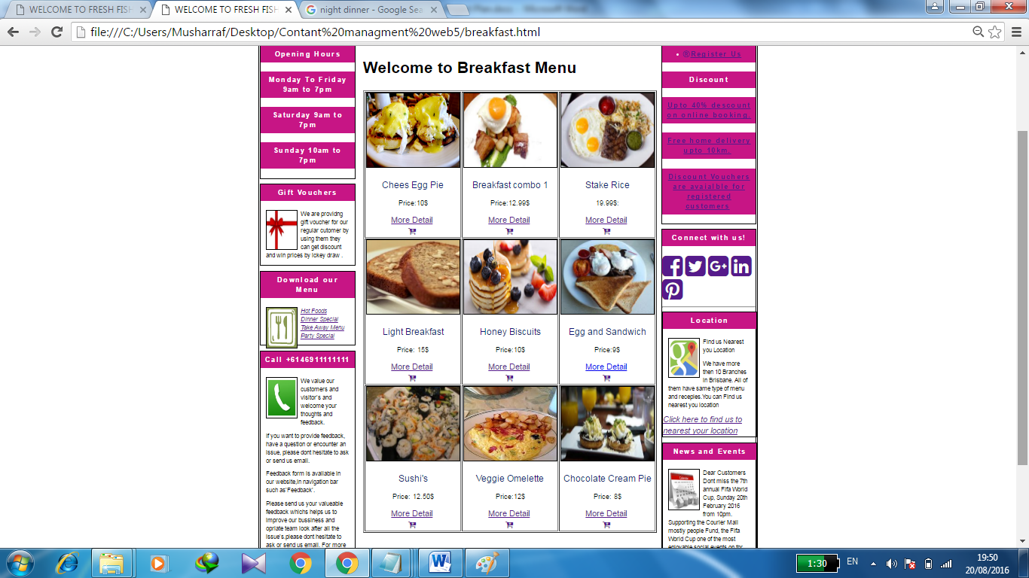

1. **LUNCH (lunch.html):**

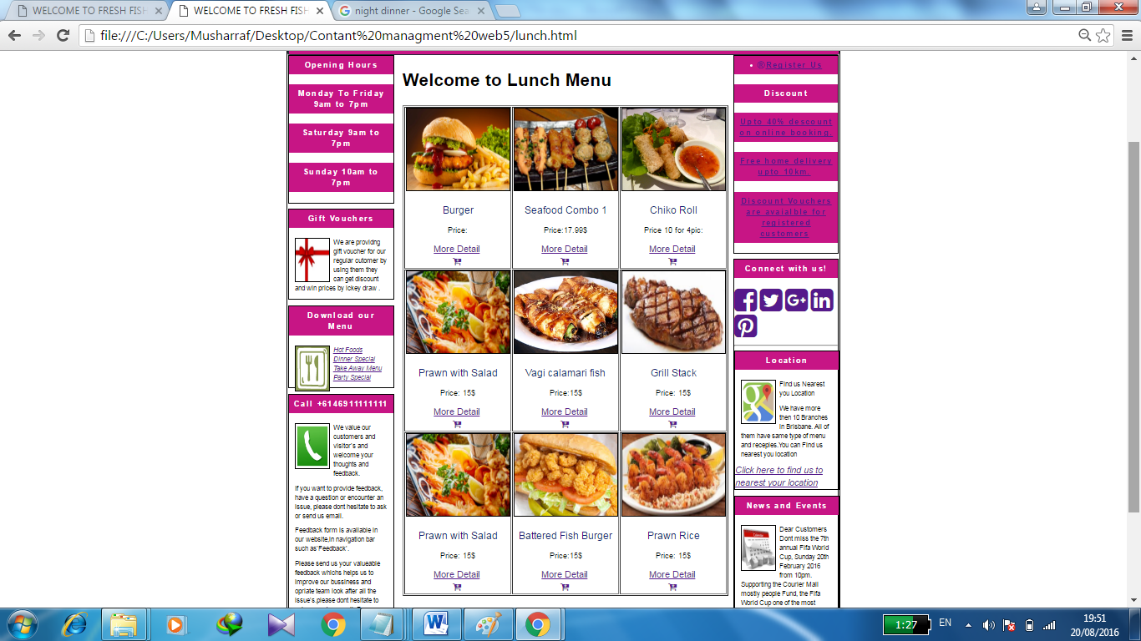

1. **Dinner (diner.html):**

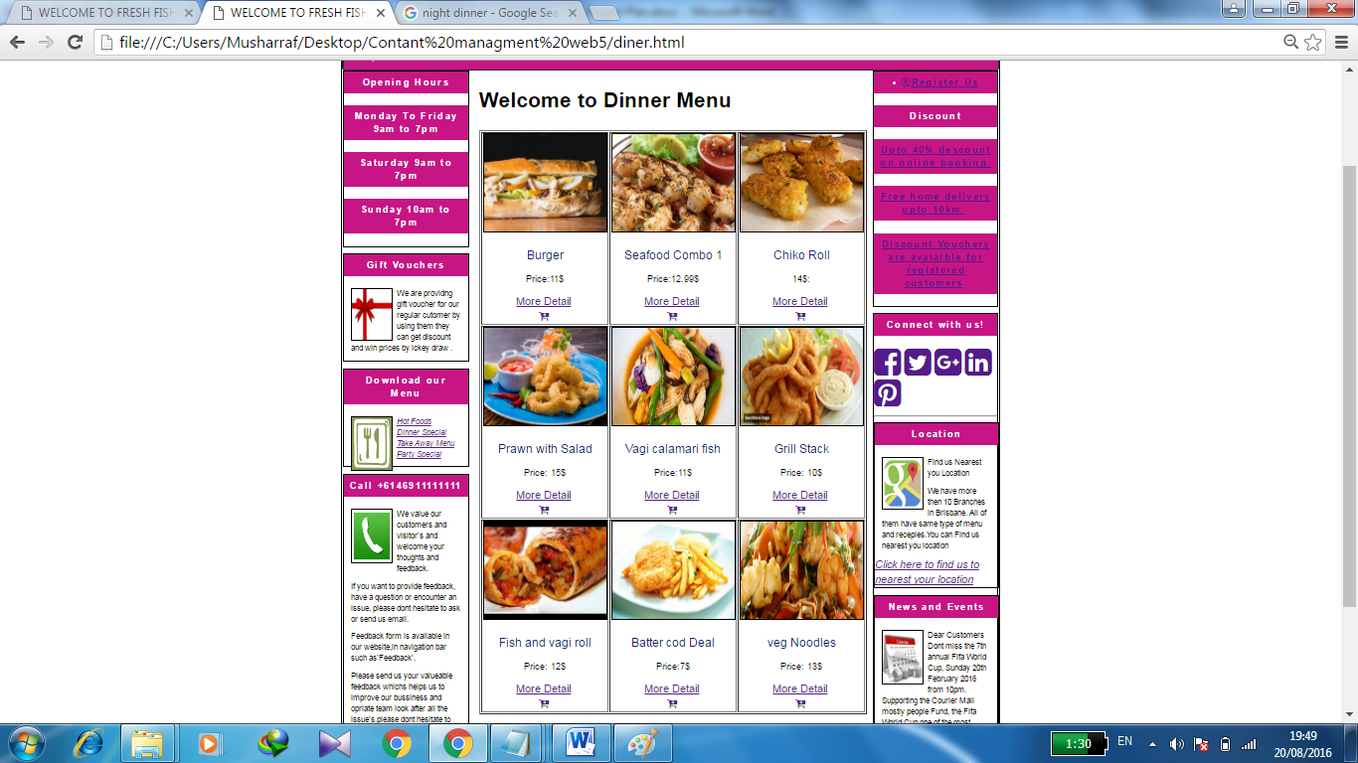

**ABOUT US (about.html):**

In about us page there is short description related to our business and food which we provides such as

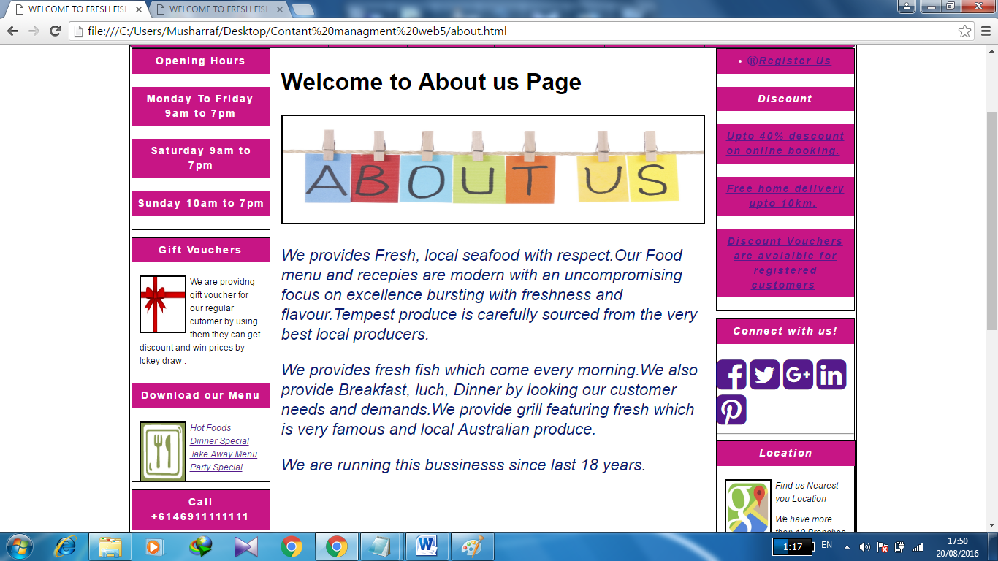

**ORDER (order.html)**

Order page (order.html) linked with order detailed page (thanks.html) and then there are 2 option either customer can put more order for this if customer click more order button is liked with menu (breakfast.html) or customer can go back to home page (index.html) by clicking back to home button such as



  
**FEEDBACK (feedback.html):**

By using feedback form customer can provide us any feedback related to our business or our services and by looking it we can improve our business and when customers submit their feedback them new page (thanks4fb.html) open to thanks to customer by their time and there feedback such as

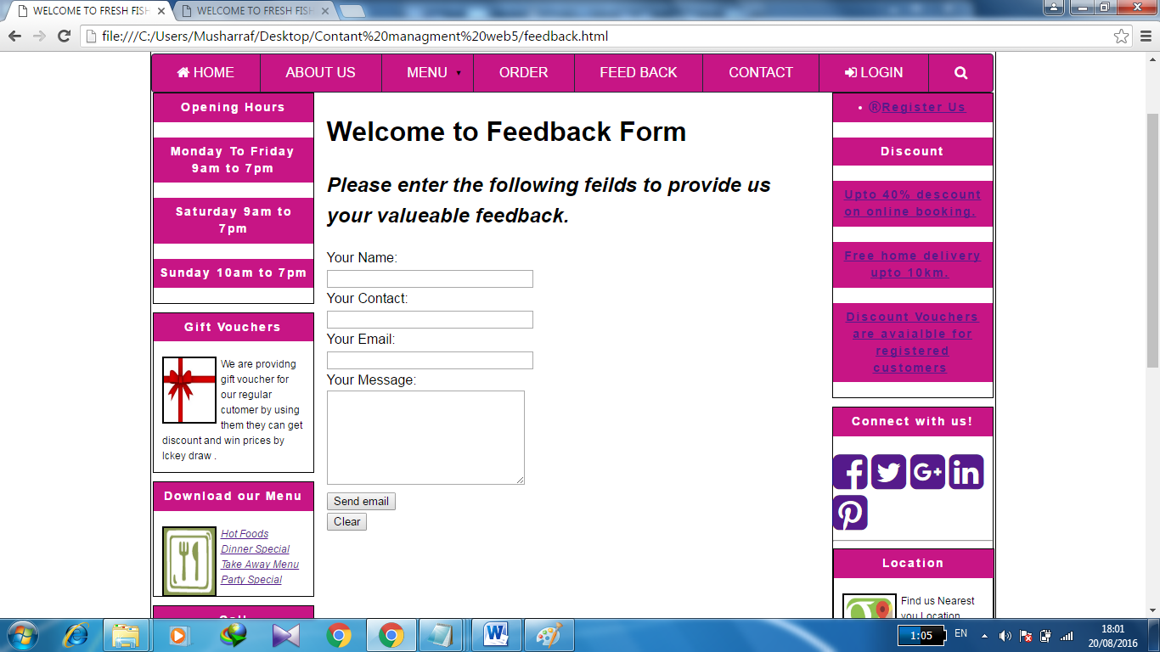

When customers send email so new page open to conferm the customers there message send and also thank for your time and interest such as

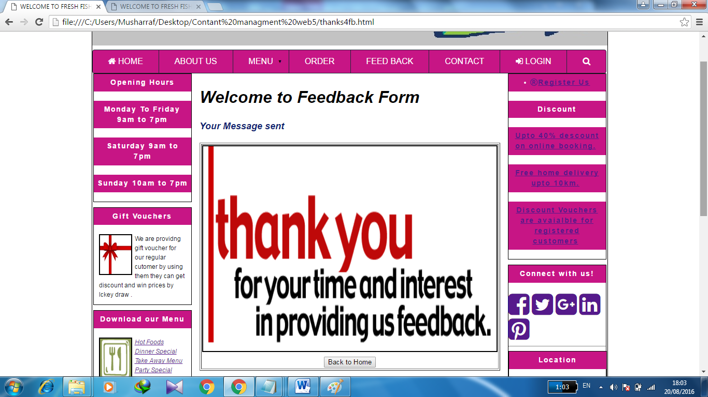

**CONTACT (contact.html):**

In contact us page customer can find our all contact details such as our shop address, contact number, shop opening and closing timings, and also our social media links as shown below.

All social media links connected with (https://www.facebook.com/mushi.rabika)

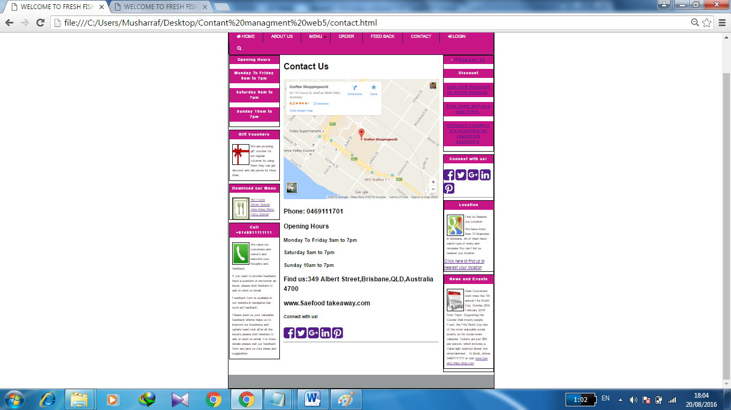

**LOGIN (login.html):**

In login page there is a form by putting user name and password registered customer can login in our website. In html website there is just image for login which shows how our login page looks like such as

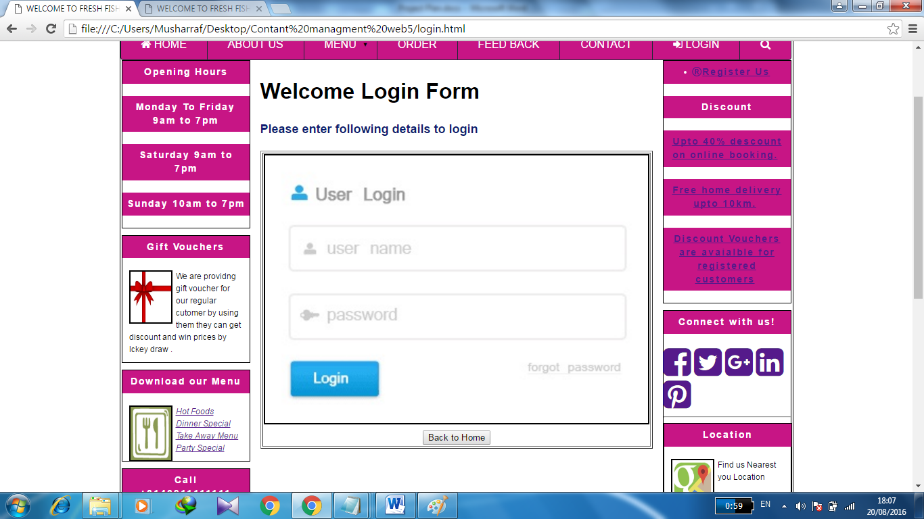

**SEARCH (search.html):**

Search page is link with menu(dnier.html) which show when customer click on search page so they can find any think what they want in our page specially all available foods as show in diagram below

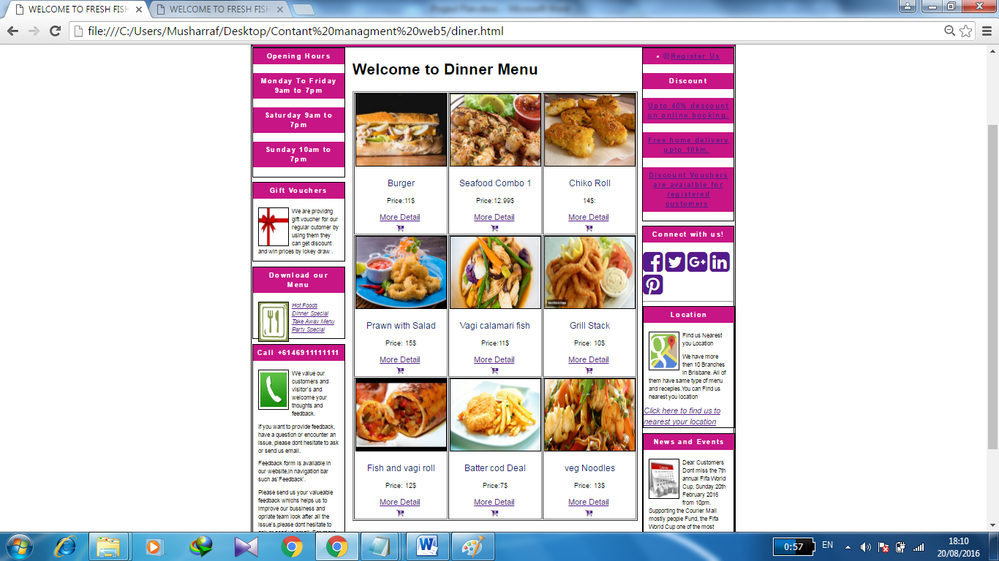

**REGISTRATION (registration.html):**

Customer can register in our website by putting some basic information and get discount vouchers and all notification such as special deals and upcoming events.

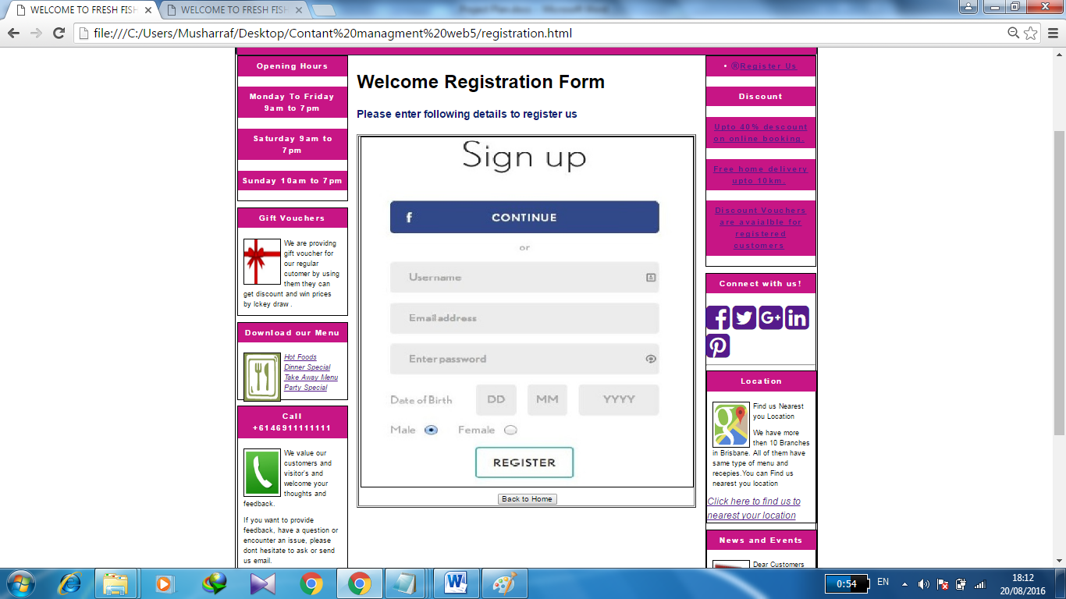

Siteground Mainpage and Plan document Links:-

<http://musharrafs.sgedu.site/a3/index.html>

<http://musharrafs.sgedu.site/a3/plan.doc>